Jenkins

Table of Contents
Jenkins 1
Jenkins on AWS 1
Install Jenkins using DOCKER 5
2. Run image with port binding 8080:8080 6
To access above path inside docker container, run below command 7
docker: Error starting userland proxy: listen tcp4 0.0.0.0:8080: bind: address already in use. 12
activate node: 15

PORT:8080

Jenkins on AWS
Follow this link for step by step installation of Jenkins on Ubuntu: https://www.trainwithshubham.com/blog/install-jenkins-on-aws

Since Jenkins is an application that built upon java, you need to install java first.
1. Update your system
sudo apt update
2. Install java
sudo apt install openjdk-11-jre
3. Validate Installation
java -version
It should look something like this
openjdk version "11.0.12" 2021-07-20 OpenJDK Runtime Environment (build 11.0.12+7-post-Debian-2) OpenJDK 64-Bit Server VM (build 11.0.12+7-post-Debian-2, mixed mode, sharing)
4. Copy commands from https://www.jenkins.io/doc/book/installing/linux/ (LTS) to add Jenkins Repo
curl -fsSL https://pkg.jenkins.io/debian-stable/jenkins.io-2023.key | sudo tee \
/usr/share/keyrings/jenkins-keyring.asc > /dev/null
echo deb [signed-by=/usr/share/keyrings/jenkins-keyring.asc] \
https://pkg.jenkins.io/debian-stable binary/ | sudo tee \
/etc/apt/sources.list.d/jenkins.list > /dev/null
sudo apt-get update
sudo apt-get install jenkins

5. Start Jenkins

sudo systemctl enable jenkins

sudo systemctl start jenkins
sudo systemctl status jenkins

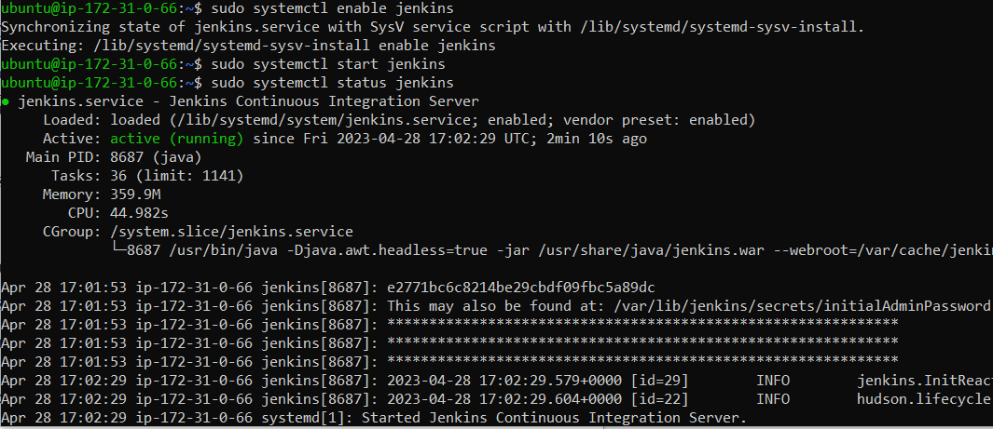

6. Open port 8080 from AWS Console:

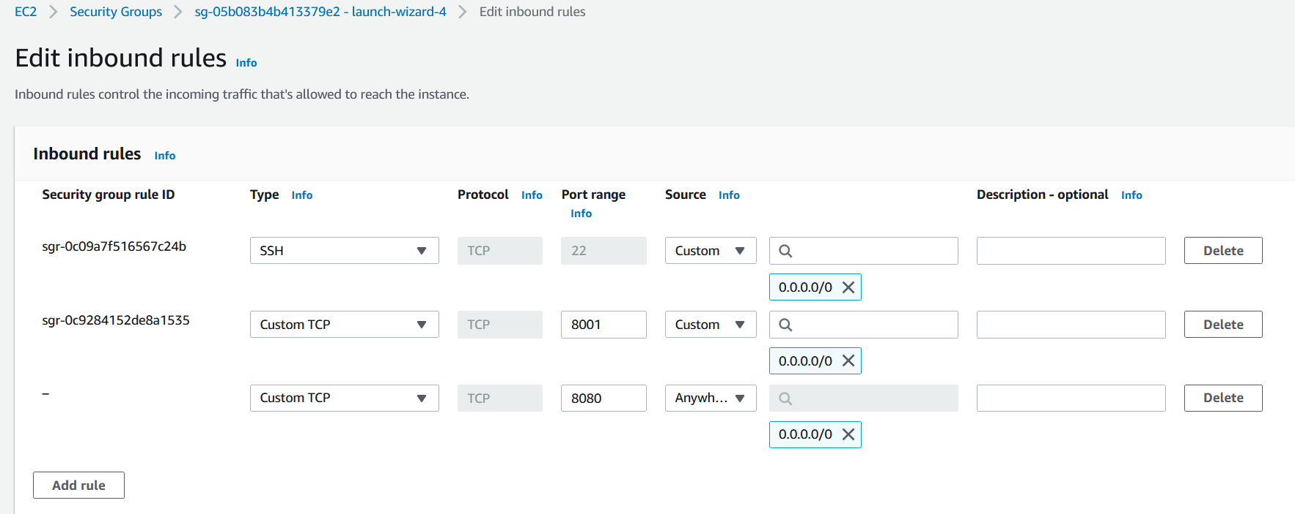

Jenkins is now up and running on PORT 8080
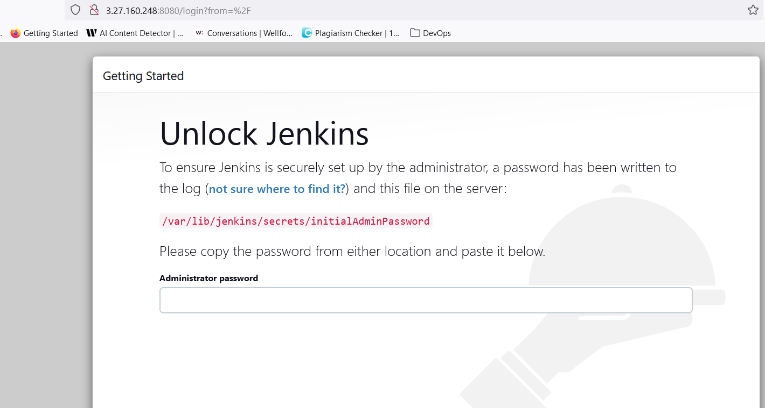

admin passwrd path: /var/lib/jenkins/secrets/initialAdminPassword

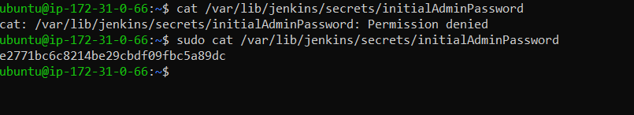
e2771bc6c8214be29cbdf09fbc5a89dc

Select suggested pipeline

create an admin user.

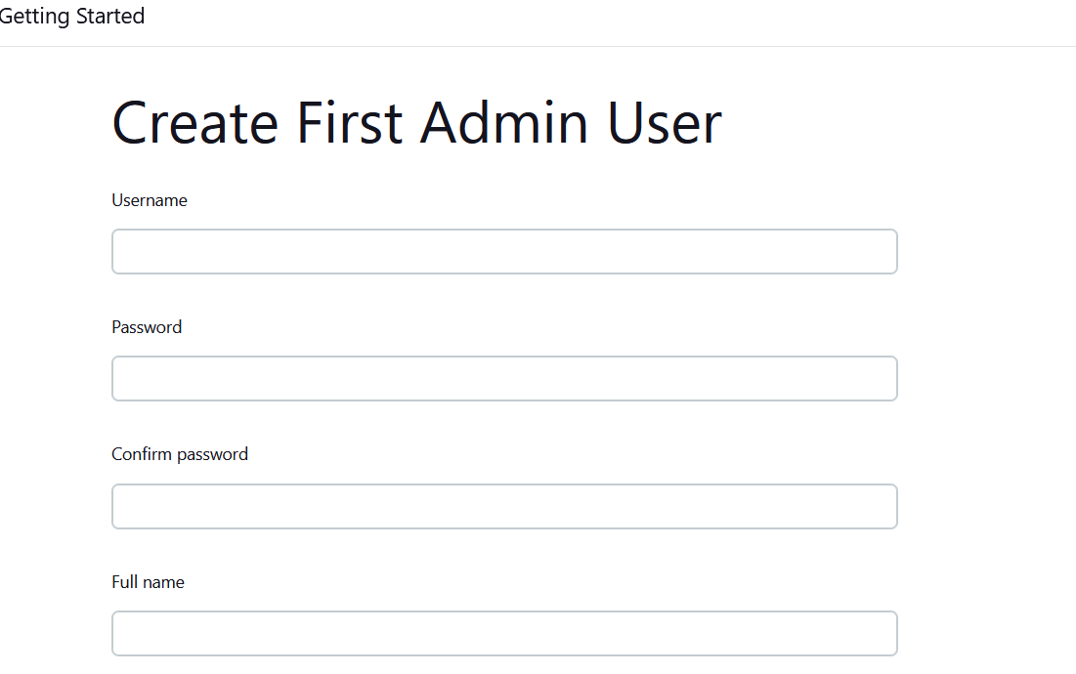

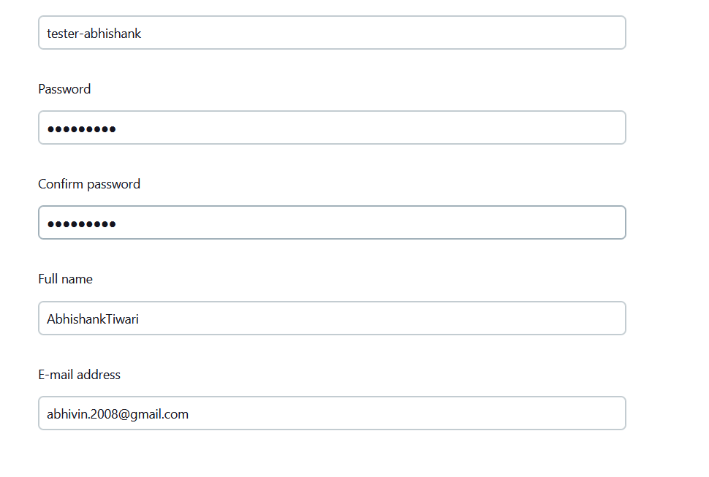

Imhere03#

-----------------------------------------------------------------------------------

Install Jenkins using DOCKER

Since only one instance of Jenkins can run in the system so we should stop jenkins first with below command:

sudo systemctl stop jenkins
sudo systemctl status jenkins

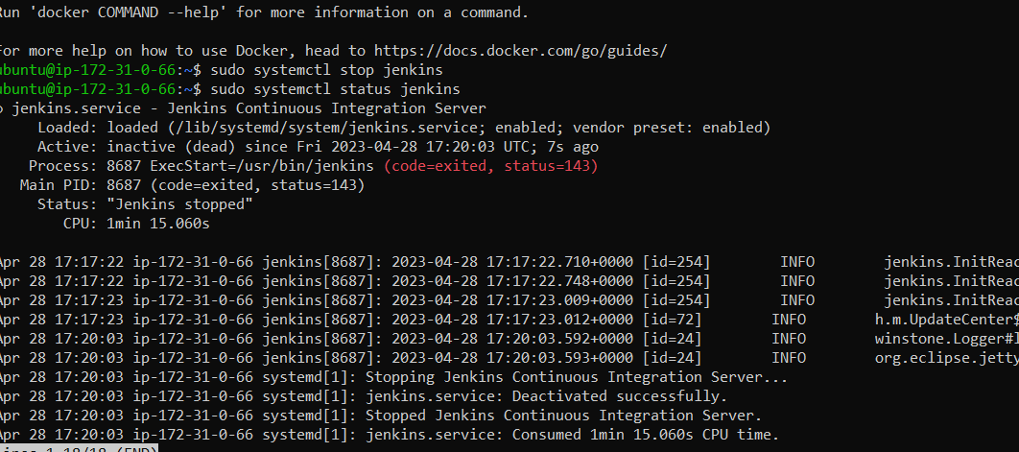

1. Install image of Jenkins using docker

sudo docker pull jenkins/jenkins

2. Run image with port binding 8080:8080

sudo docker run -d -p 8080:8080 docker.io/jenkins/jenkins:latest

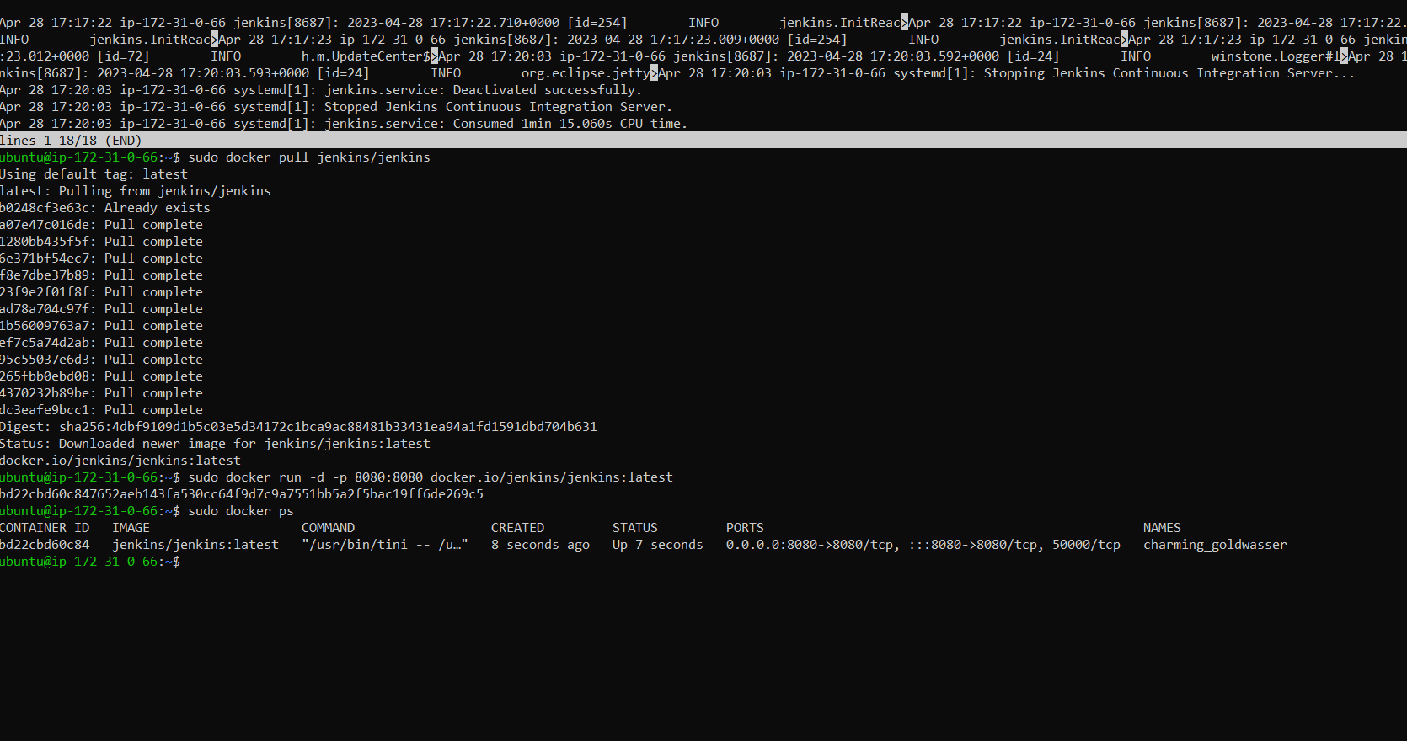

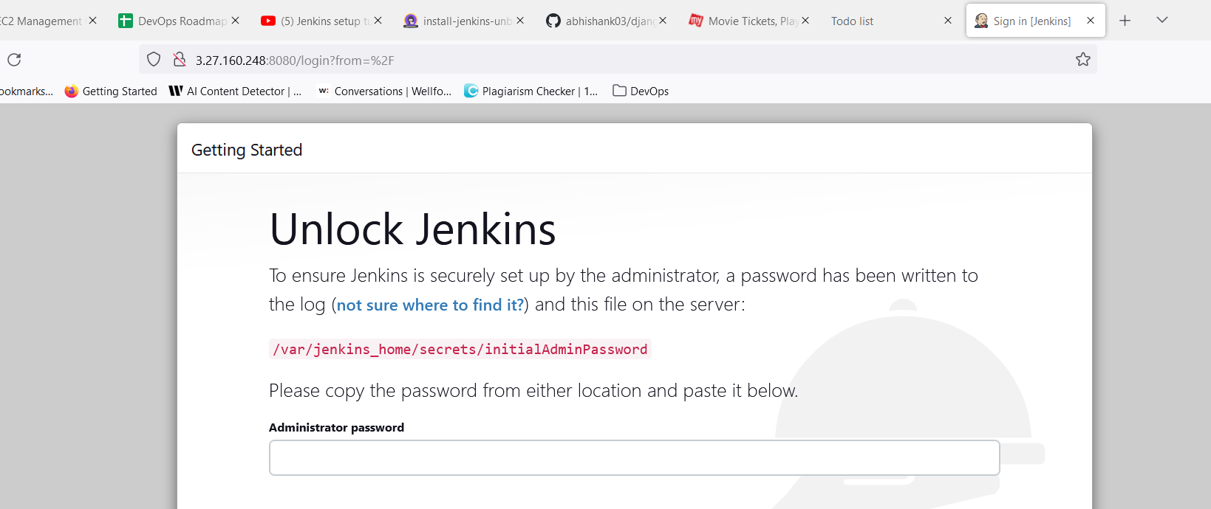

/var/jenkins_home/secrets/initialAdminPassword

To access above path inside docker container, run below command

CMD: docker exec <container> cat /var/jenkins_home/secrets/initialAdminPassword

sudo docker exec bd22cbd60c84 cat /var/jenkins_home/secrets/initialAdminPassword

9ebf8945e1a74d5d82eaff3ece4d2717

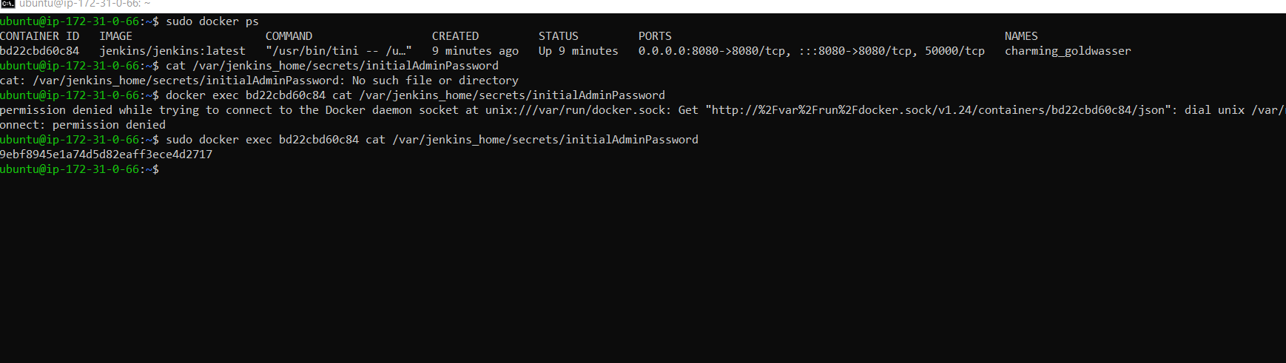

Node is an env which allow to create pipeline. Agent is responsible to execute things inside pipeline.

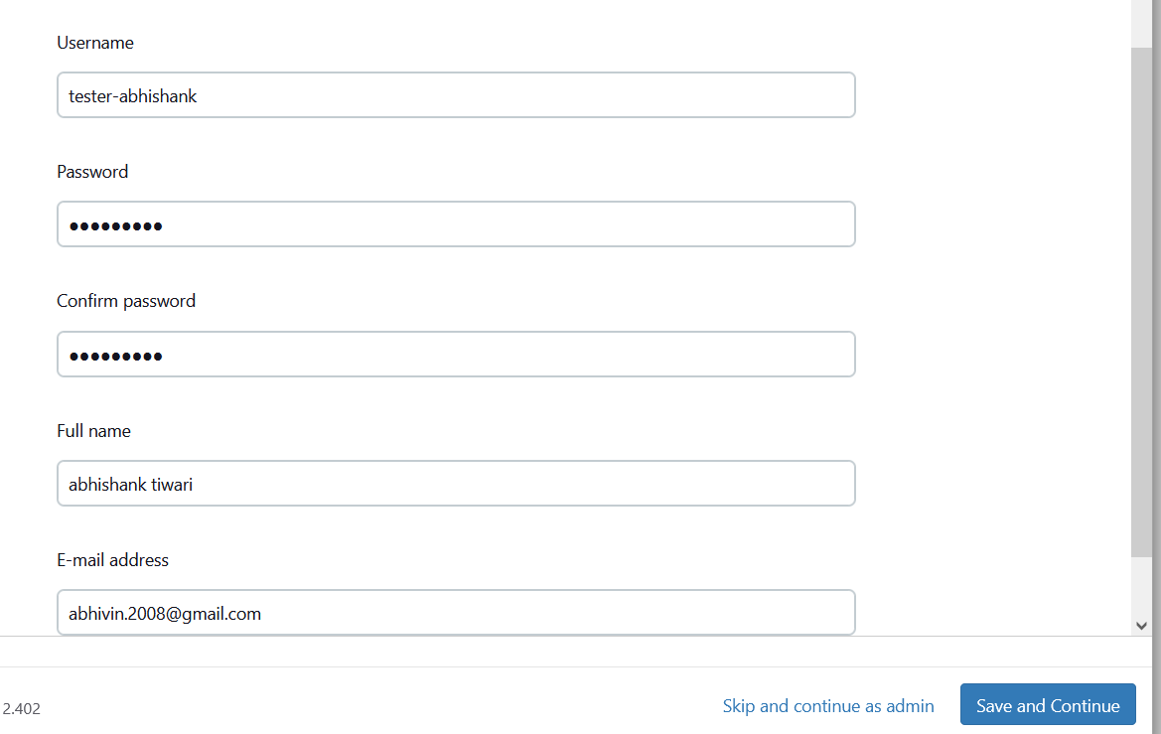
Imhere03#

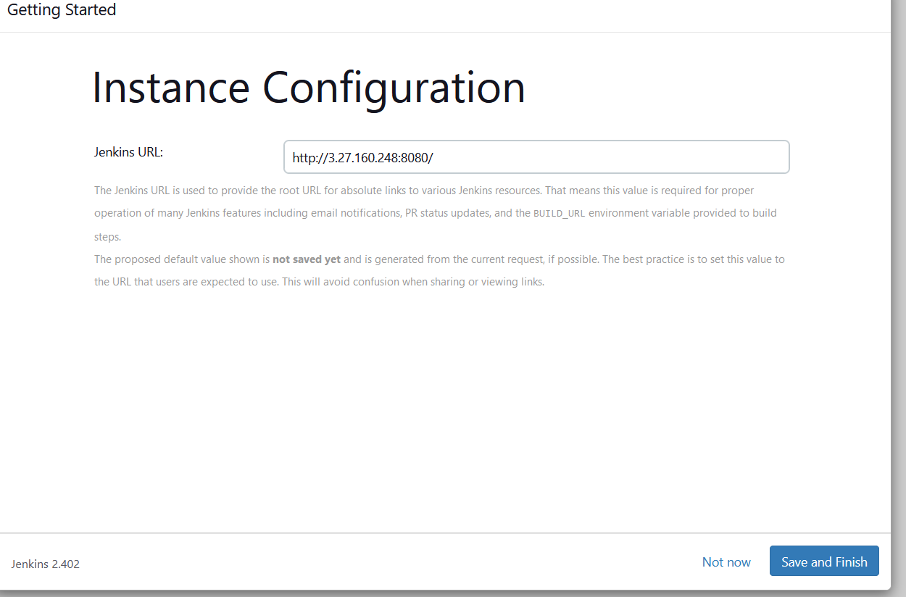

http://3.27.160.248:8080/

Setup an Agent

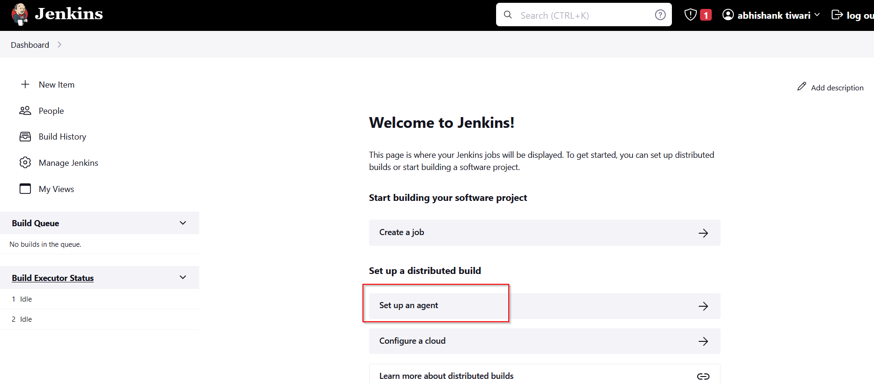

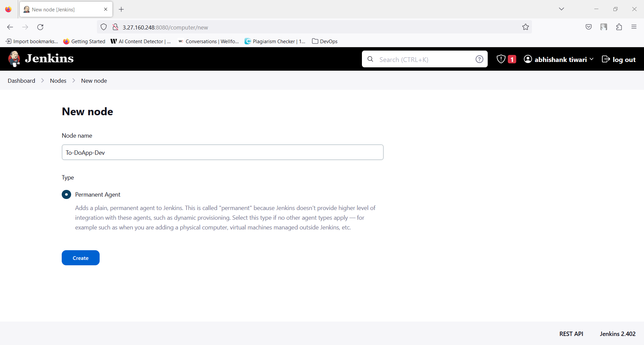

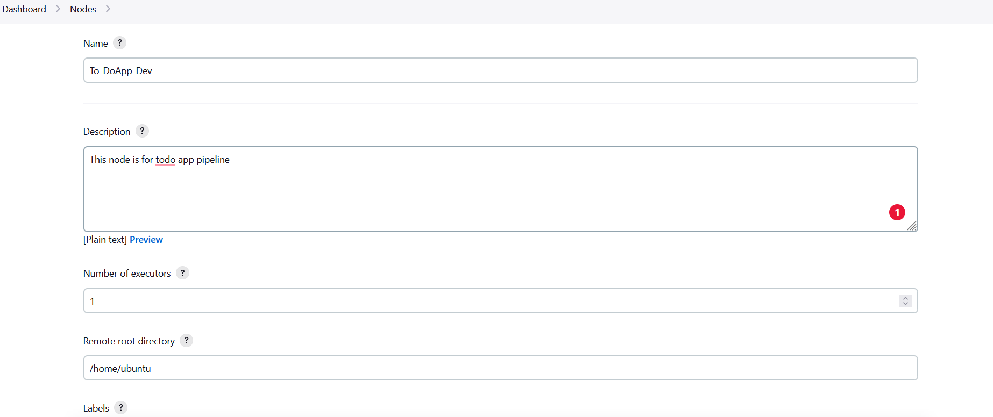

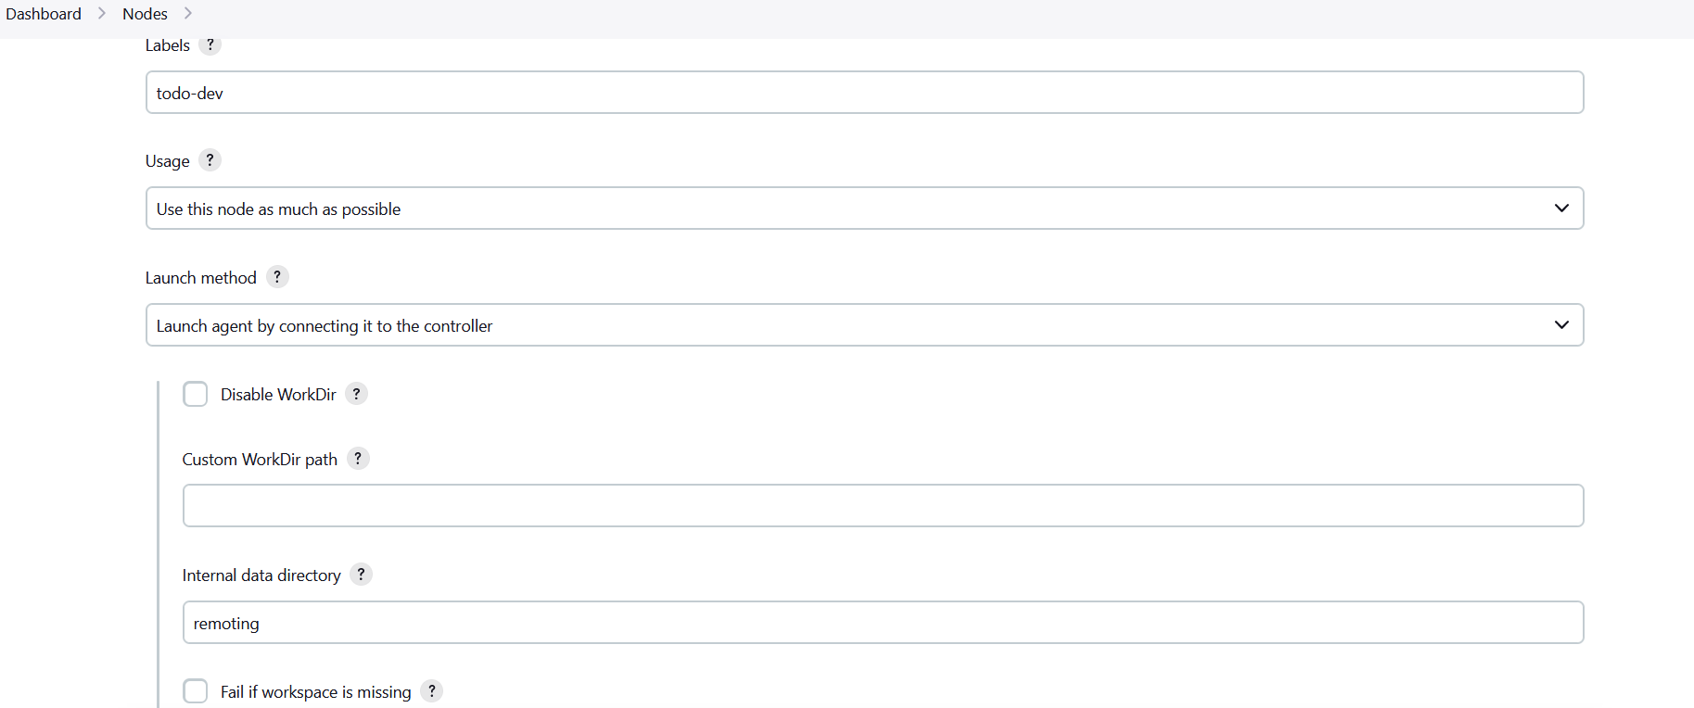

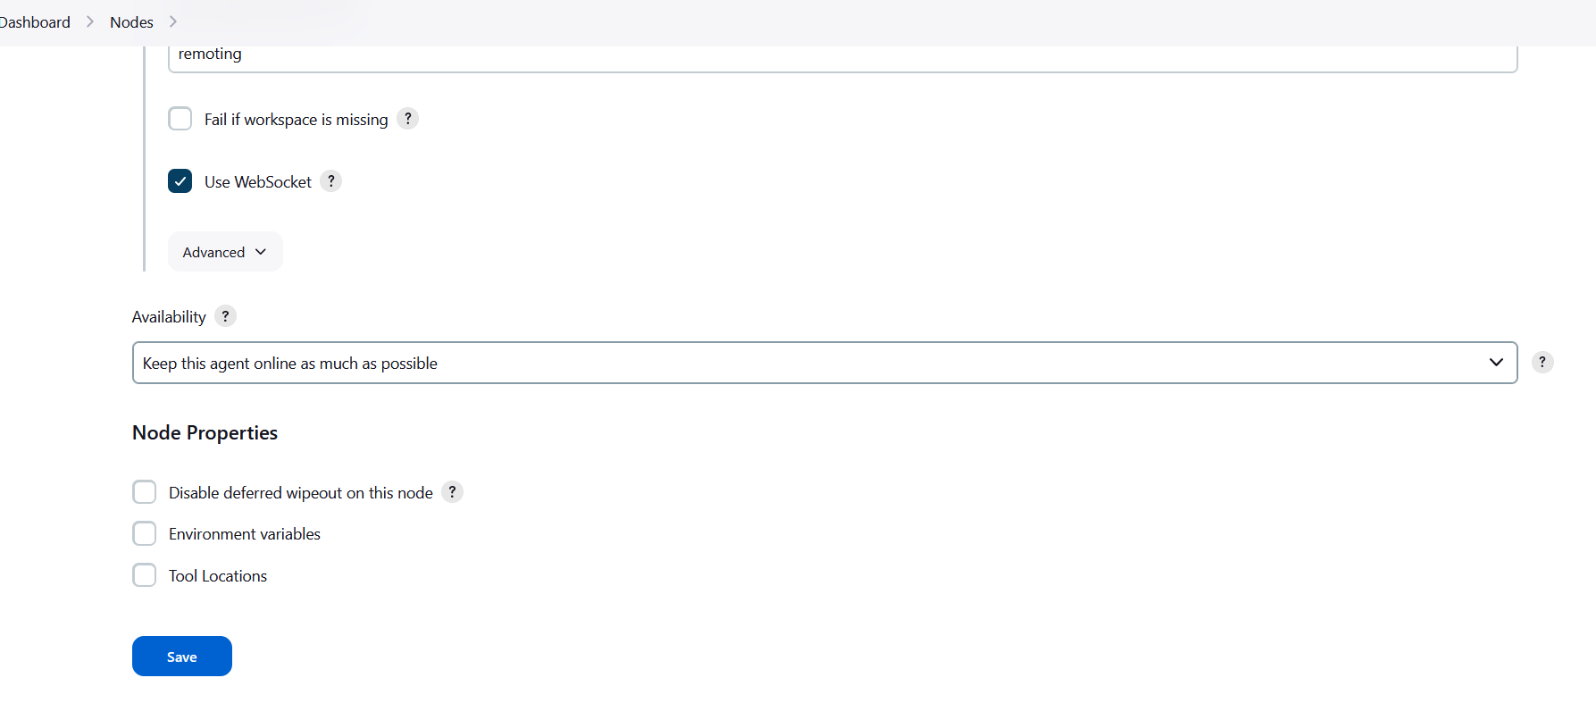

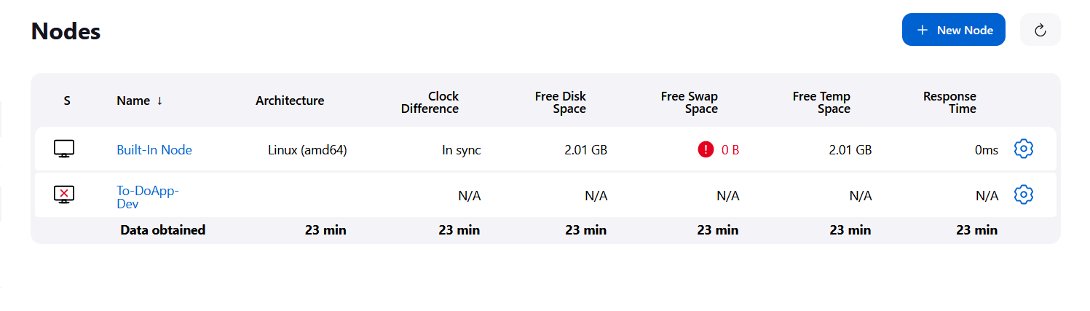

NEXT DAY:

Rerunning docker image jenkins/jenkins

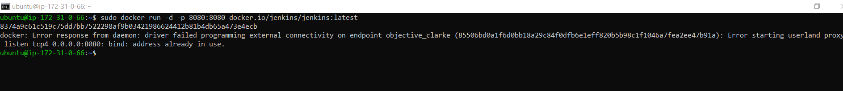

docker: Error starting userland proxy: listen tcp4 0.0.0.0:8080: bind: address already in use.

Below command will show process running at this port, then kill that process using PID (look for a PID in row) of that process.
sudo netstat -nlp | grep 8080

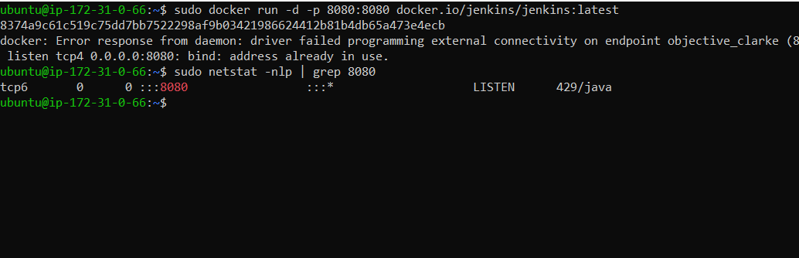
PID 429 is using port 8080
Now execute below command to kill it.
Kill PID
Kill 429
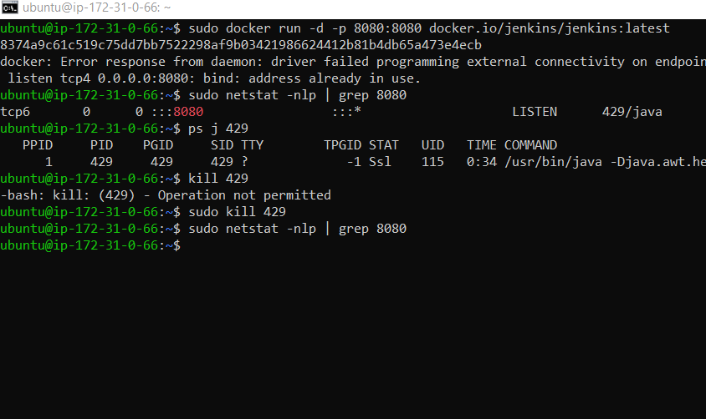
Now exec docker run command

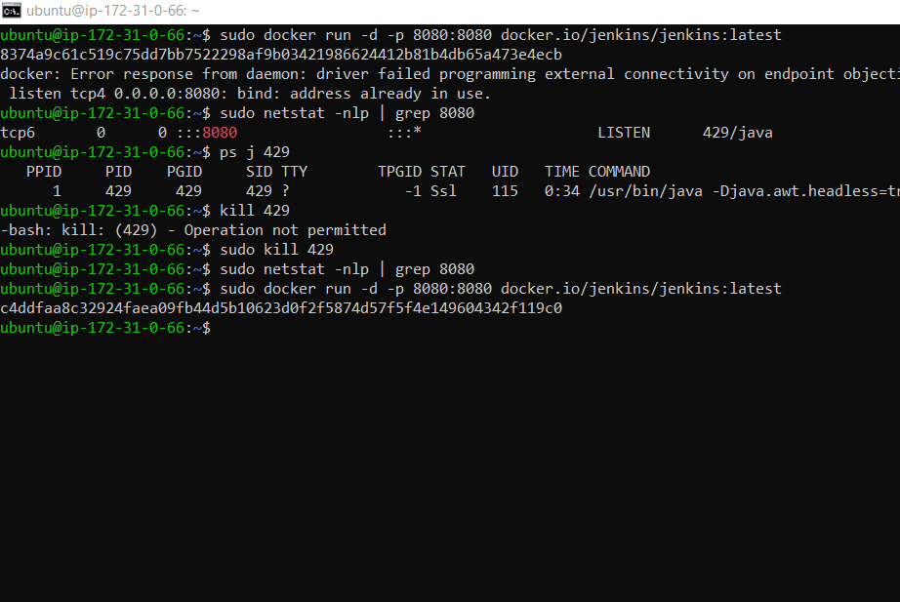

Docker is up and running
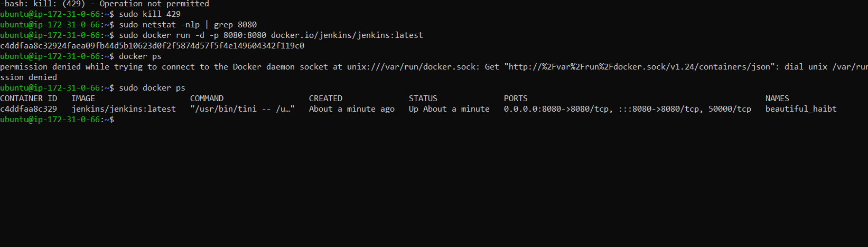

New Jenkins hashkey pwd: 3b06f37af362437bac8c66ae8050991d

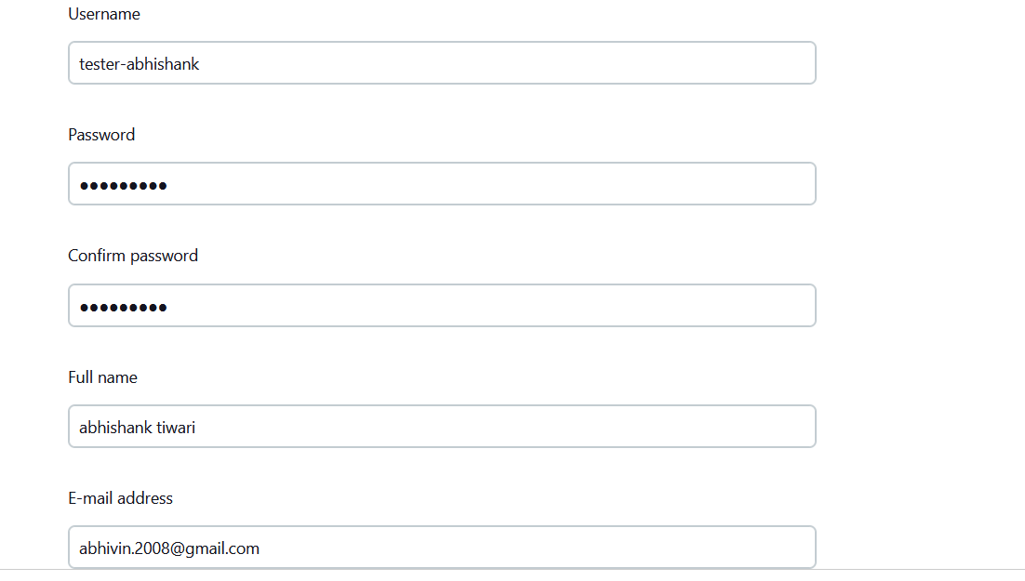

Jenkins URL: http://54.252.140.22:8080/

Create Node Name: ToDoApp-Test

activate node:
go inside node section and run given command on terminal
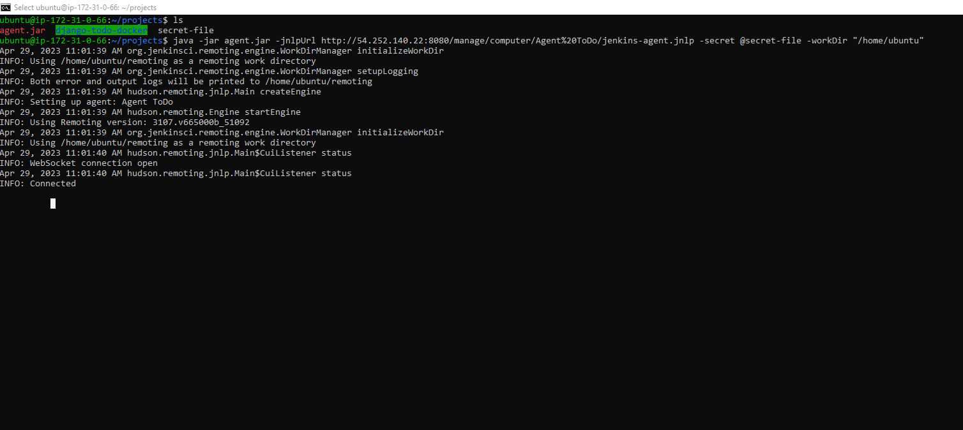

provide access to project folder with chmod 777

Create a Job and provide commands under build section

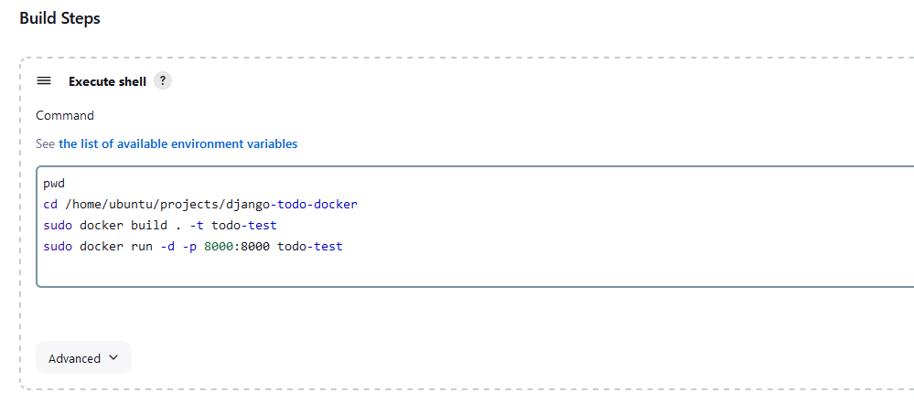
Project is up and running




